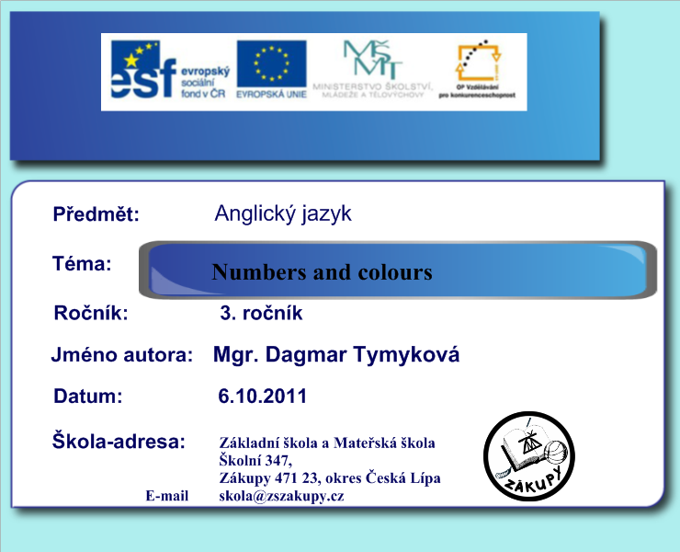

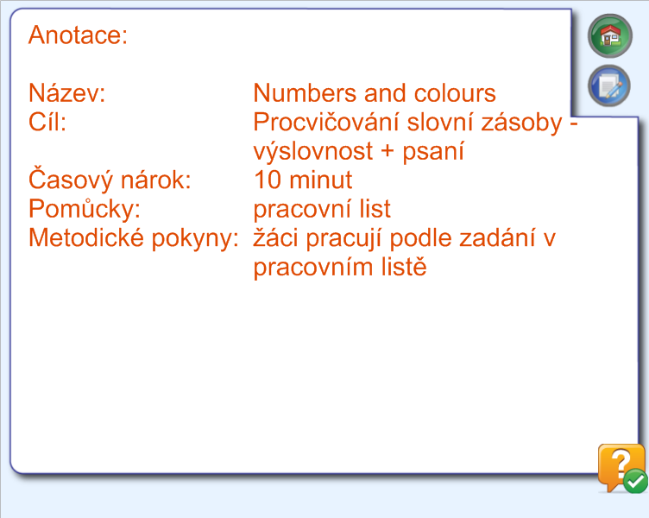

Name: …………………………………… Date:…………………….

1. Doplň písmena do slov:
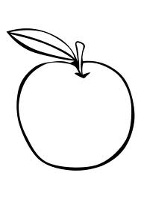
Gr _ en apple Bl_e cloud
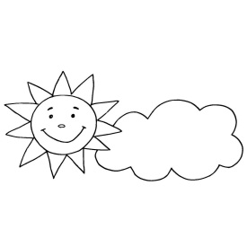
Ye_ lo _ suny g_een leaf
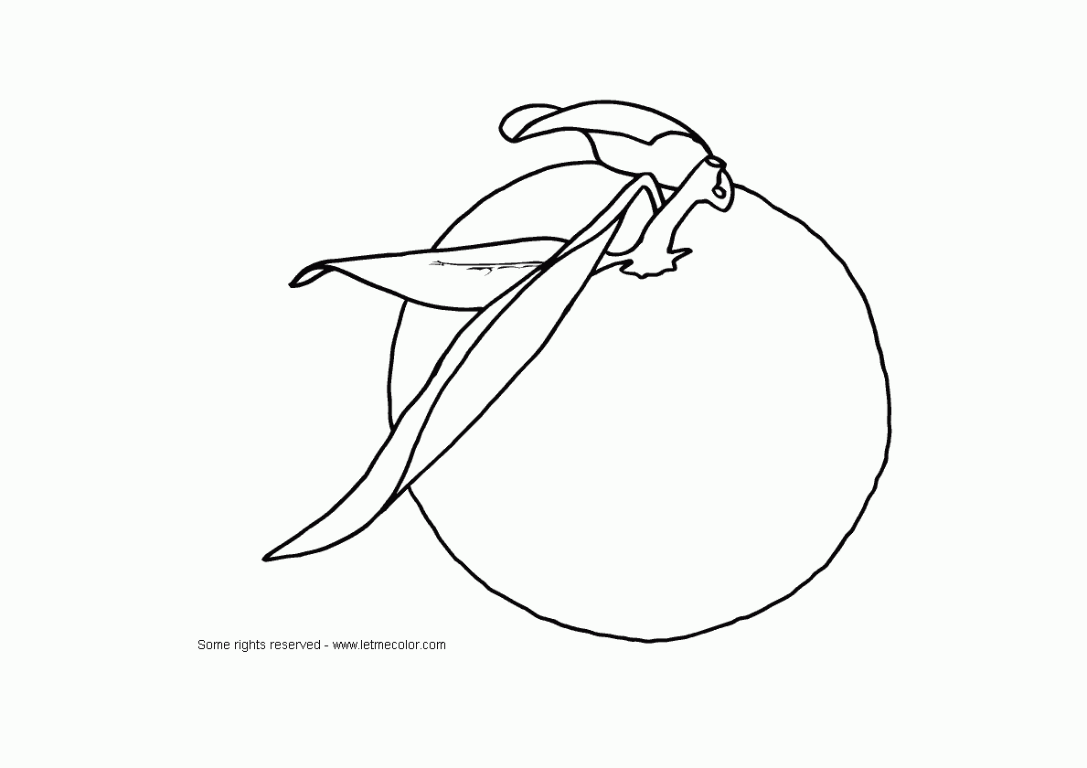

Br_ _ n mouse _ ra_ _ e orange

2. Napiš názvy číslic:

1 ………………………… five ………………………………
8 ………………………… eleven ………………………….
3 ………………………… two ………………………………
4 ………………………… six ………………………………..
7 ………………………… twelve ……………………………

Použité zdroje (odkazy)
1. jablko http://www.edupics.com/apple-t10094.jpg
2. mrak http://berusci.net/files/images/1her.gif
3. slunce http://www.predskolaci.cz/wp-content/uploads/2009/11/pocasi-slunce-mrak.jpg
4. list http://www.allkidsnetwork.com/coloring-pages/images/Fall/small/leaf-coloring-page.jpg
5. myš http://omalovanky.aspone.cz/Foto/157.jpg
6. pomeranč http://www.letmecolor.com/wp-content/uploads/2008/06/free_fruit_coloring_page_orange.gif

