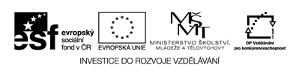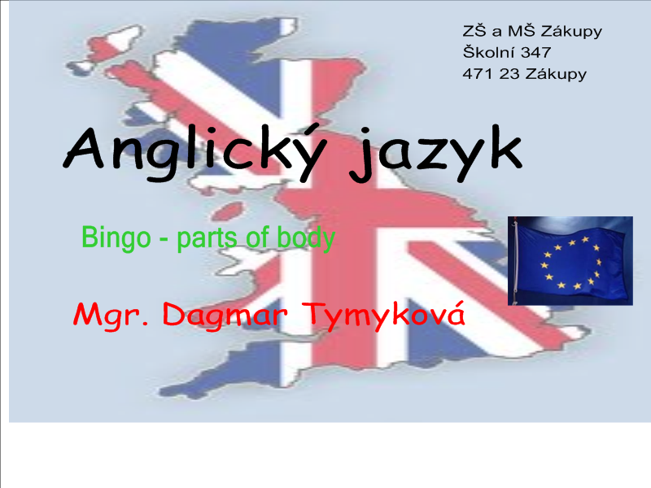

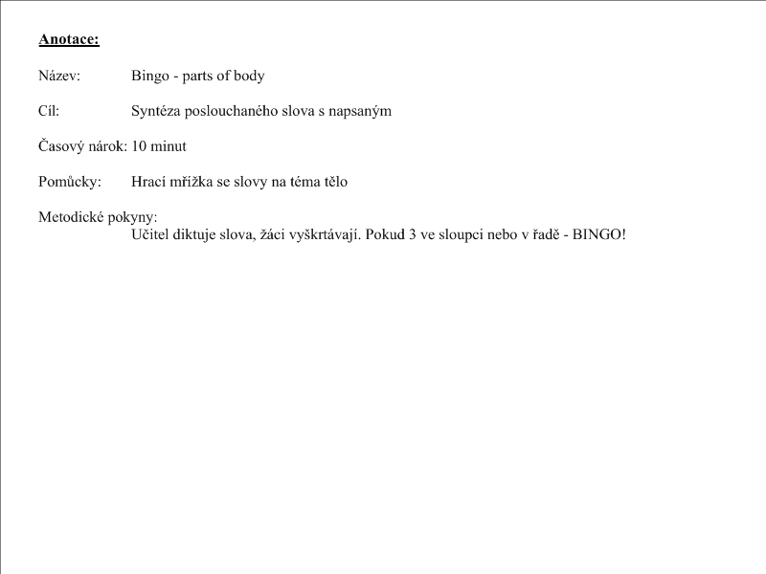

Slova: ear, body, hair, eye, hand, head, foot, arm, leg, knee, mouth, nose

- Play Bingo!!!
hand | arm | leg | hair
foot | eye | ear | knee
mouth | body | nose | head

- Play Bingo!!!
arm | mouth | leg | head
nose | eye | hair | ear
body | foot | hand | knee

- Play Bingo!!!
head | leg | arm | hair
nose | eye | body | knee
mouth | ear | foot | hand

- Play Bingo!!!
mouth | body | ear | head
leg | nose | hair | foot
eye | arm | knee | hand

