

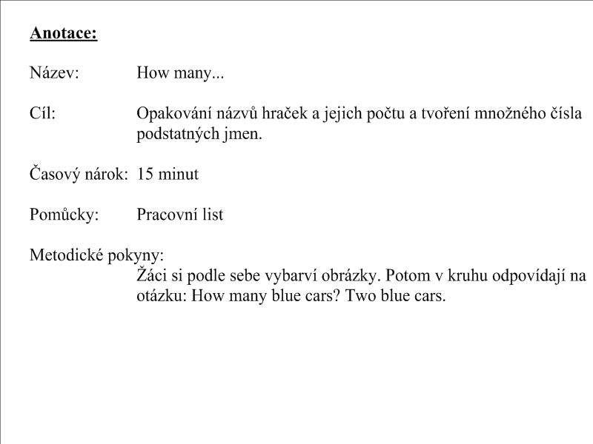

[](http://www.google.cz/imgres?imgurl=http://www.omalovankykvytisknuti.info/wp-content/gallery/Vanocni%20darky/panenka.jpg&imgrefurl=http://www.omalovankykvytisknuti.info/vanocni-omalovanky?nggpage=2&usg=__1QrBtVs_q7QfGMNoOs-XzLITuUo=&h=1115&w=836&sz=214&hl=cs&start=5&zoom=1&tbnid=AU4bMOMt-v0CrM:&tbnh=150&tbnw=112&ei=X37STfGnOcb3sgbf-KG6CQ&prev=/search?q=panenka&hl=cs&biw=867&bih=474&gbv=2&tbs=itp:lineart&tbm=isch&itbs=1)

[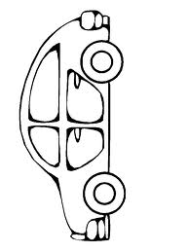](http://www.google.cz/imgres?imgurl=http://www.detskeomalovanky.cz/wp-content/auto5.gif&imgrefurl=http://www.detskeomalovanky.cz/600/rodinne-auto/&usg=__FIFPN1l2aMLaOJDPQbn1avyAT4M=&h=957&w=718&sz=11&hl=cs&start=1&zoom=1&tbnid=52dZLZlWiNuuxM:&tbnh=148&tbnw=111&ei=nX7STZqREoeztAbtqfG2CQ&prev=/search?q=auto&hl=cs&biw=867&bih=475&gbv=2&tbs=itp:lineart&tbm=isch&itbs=1)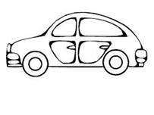

[](http://www.google.cz/imgres?imgurl=http://www.index.hr/images2/lopta000V.jpg&imgrefurl=http://www.index.hr/xmag/clanak/humane-zvijezde-vracaju-se-u-akciju/340255.aspx&usg=__VAYqsQDw-QwNSwMrUSipb4SD_xU=&h=293&w=293&sz=13&hl=cs&start=8&zoom=0&tbnid=Wnh4tq4XdFj5gM:&tbnh=115&tbnw=115&ei=3X7STdpyjO76BonArL4K&prev=/search?q=m%C3%AD%C4%8D&hl=cs&biw=627&bih=314&gbv=2&tbs=itp:lineart&tbm=isch&itbs=1&iact=rc&dur=227&page=2&ndsp=10&ved=1t:429,r:1,s:8&tx=40&ty=39)

[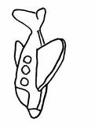](http://www.google.cz/imgres?imgurl=http://www.detskeomalovanky.cz/wp-content/letadlo2.gif&imgrefurl=http://www.detskeomalovanky.cz/677/letadlo-2/&usg=__bgpl14hSSLR5BrBmVzVkZN6tQtM=&h=957&w=718&sz=12&hl=cs&start=0&zoom=1&tbnid=YqvG0dGdTcw5KM:&tbnh=101&tbnw=76&ei=BX_STcf5CorTtAb5nIytCQ&prev=/search?q=letadlo&hl=cs&biw=627&bih=313&gbv=2&tbs=itp:lineart&tbm=isch&itbs=1&iact=rc&dur=4&page=1&ndsp=10&ved=1t:429,r:1,s:0&tx=43&ty=48)

[](http://www.google.cz/imgres?imgurl=http://www.omalovanky.biz/omalovanky/auta/omalovanka-raketa.gif&imgrefurl=http://www.omalovanky.biz/omalovanka.html?kategorie=auta&omalovanka=raketa&usg=__nsBGz620kmOSzqpJ2hlwLjqTPoo=&h=737&w=567&sz=14&hl=cs&start=5&zoom=1&tbnid=MajoDF1rRrDDfM:&tbnh=141&tbnw=108&ei=fH_STd-gE8eDswaYsNyjCQ&prev=/search?q=raketa&hl=cs&biw=867&bih=474&gbv=2&tbs=itp:lineart&tbm=isch&itbs=1)

[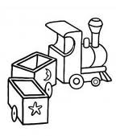](http://www.google.cz/imgres?imgurl=http://www.omalovanka.com/omalovanky/auta-letadla-vlaky/thumbs/omalovanka-dreveny-vlak.jpg&imgrefurl=http://www.omalovanka.com/omalovanky-auta-letadla-vlaky.html&usg=__hLwNO_MkSBsO_auWiTnvfasidu4=&h=212&w=180&sz=8&hl=cs&start=7&zoom=1&tbnid=aSQq82276qrFxM:&tbnh=106&tbnw=90&ei=_X_STd2UEcfPsgbH8dizCQ&prev=/search?q=vlak&hl=cs&biw=867&bih=475&gbv=2&tbs=itp:lineart&tbm=isch&itbs=1)