

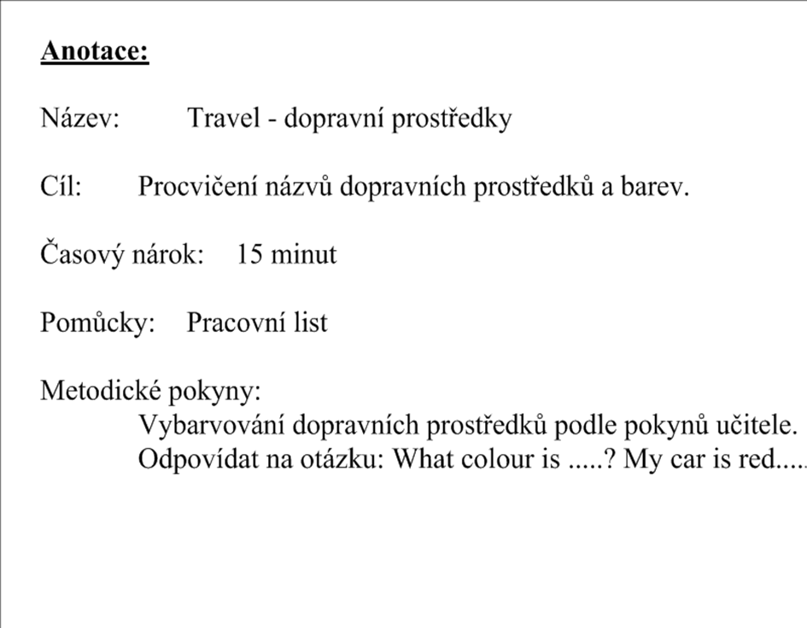

[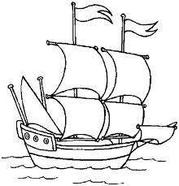](http://www.google.cz/imgres?imgurl=http://janoch.borec.cz/omal_2/1_lod.gif&imgrefurl=http://janoch.borec.cz/omal_2/omalovanky.html&usg=__eoMYHO6zpjf9r9z_NfvLspV6HWQ=&h=698&w=670&sz=11&hl=cs&start=0&zoom=1&tbnid=YD3xwR1W9ON5SM:&tbnh=148&tbnw=142&ei=snXSTdXpM9HLsgbeovjCCQ&prev=/search?q=lo%C4%8F&hl=cs&biw=867&bih=474&gbv=2&tbs=itp:lineart&tbm=isch&itbs=1&iact=rc&dur=550&page=1&ndsp=9&ved=1t:429,r:2,s:0&tx=86&ty=97) 